**Capstone Project - The Battle of Neighborhoods**

**UK Cities Restaurants Analysis**

Table of Contents

**1. Introduction: 3**

**1.1 Business Problem Background: 3**

**1.2 Interest 3**

**2. Data: 4**

**2.1 Methodology: 5**

**3. Conclusion: 8**

## Introduction:

The aim of this project is to demonstrate how Foursquare API can be used in conjunction with other databases to search and explore and certain cities of choice and to demonstrate how a business problem can be solved using it and give further recommendations for business groups.

### **1.1 Business Problem Background:**

The goal of this is to create a business plan by the end, the business problem that we are trying to solve here, is one of the crucial problems nowadays.

A lot of people are targeting to start a business in a different country and one of the problems that they face is related to understand some basic information about the foreign country that they are targeting.

One of these fields of business is the restaurant business.

The information that we are targeting to collect by this project is the understanding of the necessity to have a restaurant in a specific city based on the current restaurants serving this city and the population of the city itself.

Understanding the need of a certain region to have extra restaurants is a fundamental information to take a decision based on it.

Using Foursquare API along with some database about UK, I'll create a program to answer this question.

### **1.2 Interest**

People who would be interested in such information, are mainly businessmen in the restaurant business targeting to have a new restaurant in a new country or a city.

Also, some countries are giving entrepreneur visa based on some business plan and investments on a certain city in the target country, so it would be a very helpful information for these people to know which city can be a target to for their business.

## Data:

This project is mainly based on:

* Foursquare Data location API.
* United Kingdom Cities Database from "simplemaps" site <https://simplemaps.com/data/gb-cities>.

**The UK data file includes some information about the cities of UK :**

* City
* Lat
* Lng
* Country
* iso2
* admin_name
* capital
* population
* population_proper

Step 1 - Extracting UK Data File:

the idea here is to get information from the CSV file of UK and convert it to a data frame including the city name, coordinates (longitude and latitude) and population per city.

Step 2 – Foursquare API:

After that we will be using the Foursquare API with the Search capability to get all restaurant venues per city.

Step 3 – Clustering:

After compiling all information that we got from the UK database and the Foursquare API, we will end up with a database including 4 major information:

1. City Name (all UK cities).
2. Population Per city.
3. Number of restaurants per city.
4. Restaurant per 100K capita. (an indication feature of how many restaurants exists in a city per 100K person).

## Methodology:

## Import all necessary libraries.

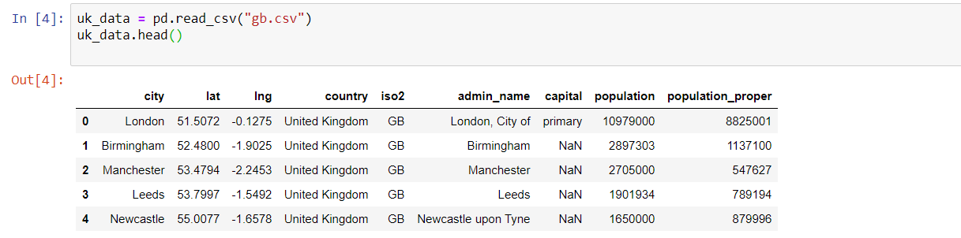import data from "[https://simplemaps.com/data/gb-cities"](https://simplemaps.com/data/gb-cities%22) site which includes data about UK cities items of population and coordinates

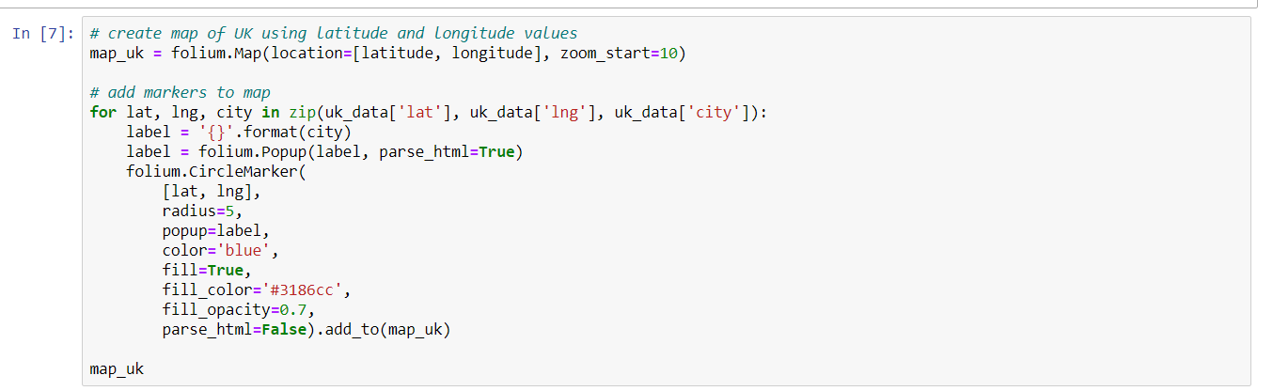Create a map of all UK showing all projected 443 cities

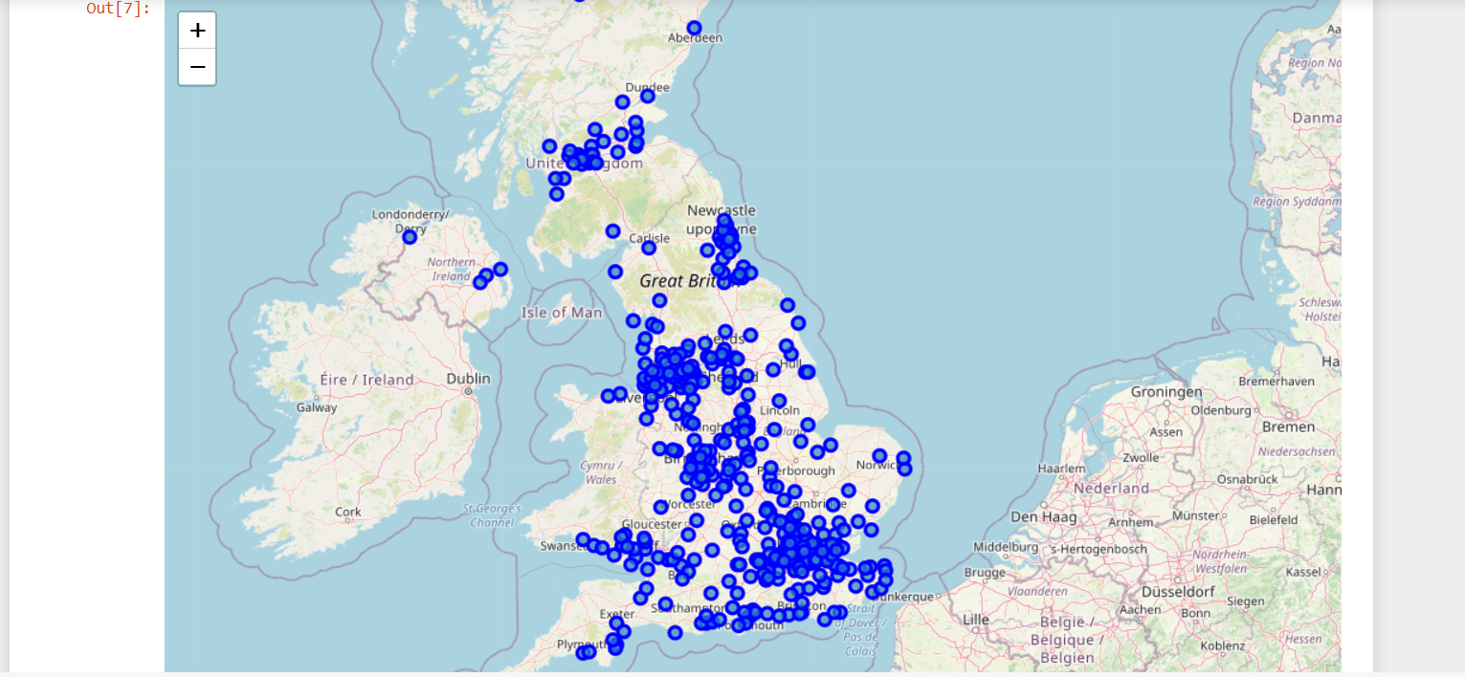

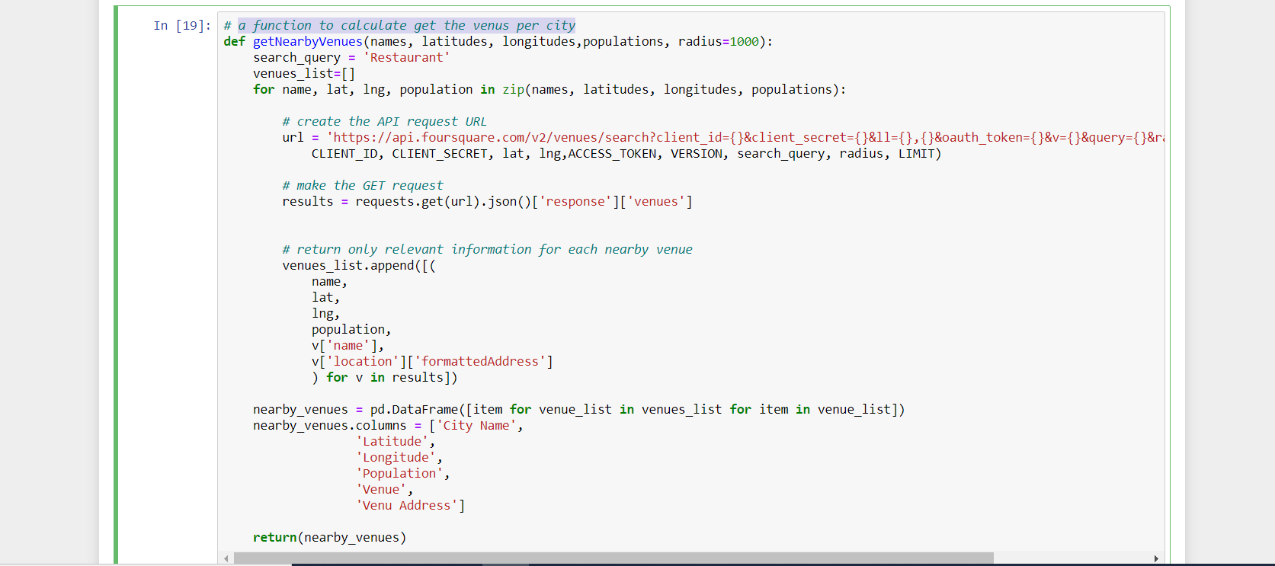Function to calculate get the venues per city

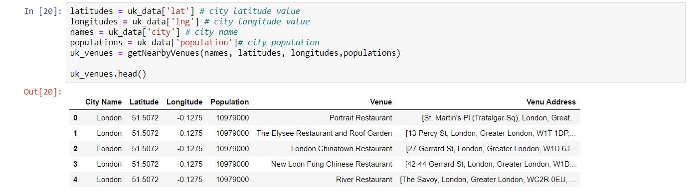A data frame created to capture all restaurant venues in all cities of UK

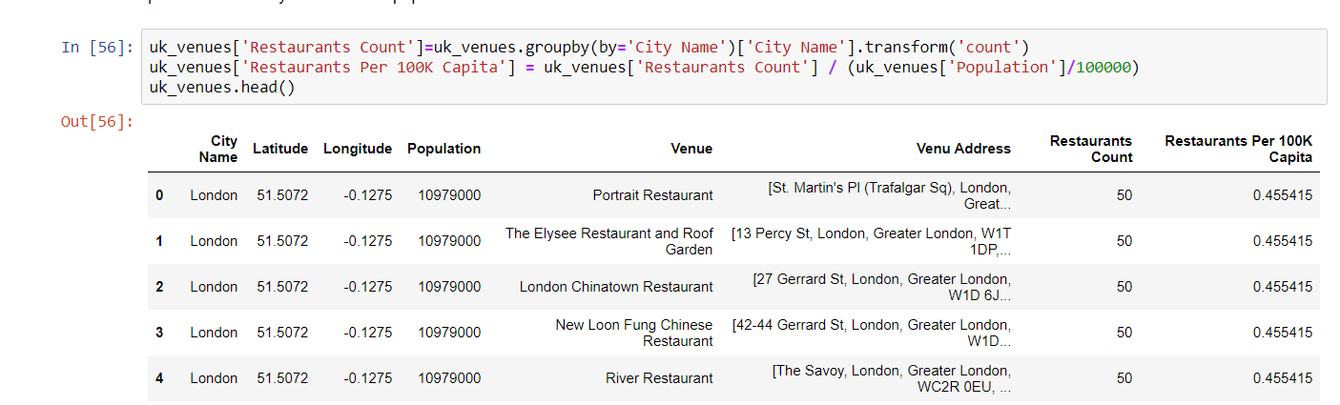A data frame including all required features with the count of restaurants per city and the restaurants per 100K person in city

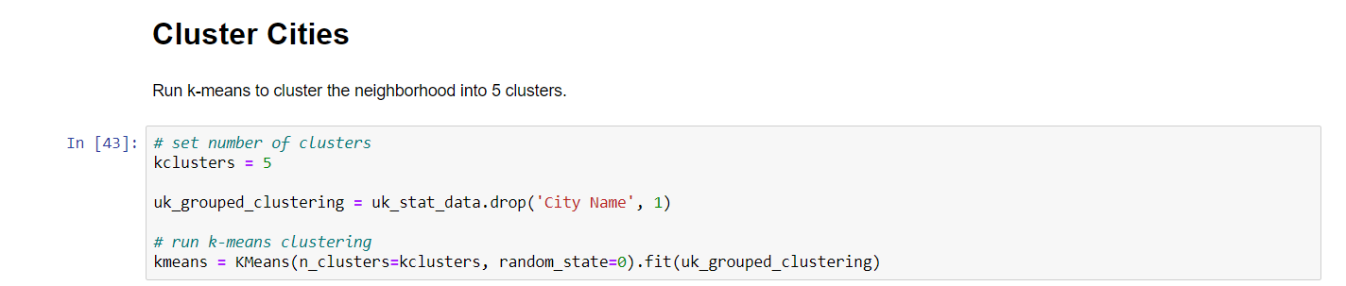Creating 5 clusters to show all cities based on k-means clustering

Clusters merged with the data frame showing all other information

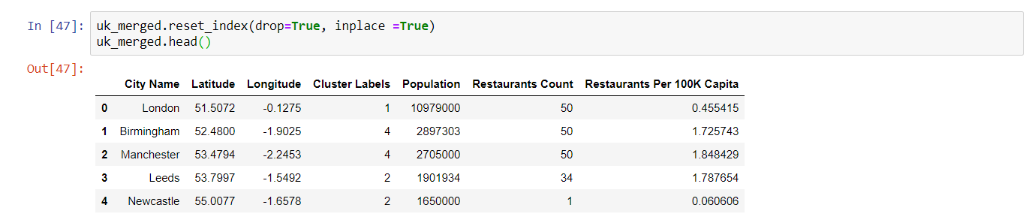

## Conclusion:

Five different clusters were produced based on the data we collected during this project including population per city, number of restaurants per city and the Restaurant per 100K capita.

*Cluster 1*: including 357 cities with population below 1 Million and restaurant per 100K capita above 1.0. (Low Population – High Restaurant Count)

*Cluster 2*: including 1 city with population above 10 Million and restaurant per 100K capita below 1.0. (Very High Population – Low Restaurant Count)

*Cluster 3*: including 3 cities with population above 1 Million and restaurant per 100K capita above and below 1.0. (High Population – Low Restaurant Count)

*Cluster 4*: including 11 cities with population below 1 Million and restaurant per 100K capita above 1.0. (Low Population – High Restaurant Count)

*Cluster 5*: including 2 cities with population above 2 Million and restaurant per 100K capita above 1.0. (High Population – High Restaurant Count)

From above clustering it is clear for a restaurant business that clusters with "Low Restaurant Count" would be their first choice of city location and then other can follow in terms of priority

Priorities for choosing a city to open a restaurant will be from prepared clusters as follows: Cluster 2 –-> Cluster 3 –-> Cluster 5 –> Cluster 4 –> Cluster 1.

Top 4 Cities to open a restaurant in are:

1. London.
2. Newcastle.
3. Birstall.
4. Leeds.

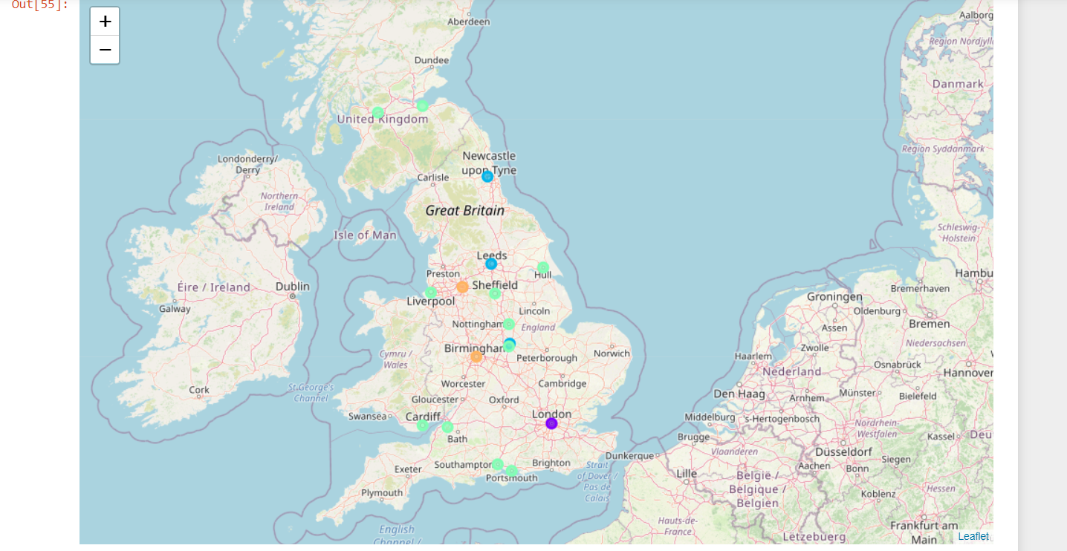A map showing the best clusters

Link to the detailed Notebook file of the code on Github:

[**https://github.com/ahmedrashwan66/Capstone-Project---The-Battle-of-Neighborhoods-UK-Cities-Restaurants-Analysis-/blob/fb250725e8899a5fde1138876e463f8cf09cb209/Capstone%20Project%20-%20The%20Battle%20of%20Neighborhoods%20(1).ipynb**](https://github.com/ahmedrashwan66/Capstone-Project---The-Battle-of-Neighborhoods-UK-Cities-Restaurants-Analysis-/blob/fb250725e8899a5fde1138876e463f8cf09cb209/Capstone%20Project%20-%20The%20Battle%20of%20Neighborhoods%20(1).ipynb)